

Traffic Light using ATmega32
Computer Microprocessor
EEC 214
Group | ID | NAME
4 | 20243160 | Mohamed Hazem Gouda
4 | 20243147 | Moataz Mohamed Rajab
4 | 20243148 | Mohanad Mohamed Rajab
4 | 202431 | Saad Abdullah

Submitted To:
DR: Mohamed Torad

Abstract:
This project presents the design and implementation of a smart traffic light control system for a four-road intersection using the ATmega32. The system controls traffic flow by operating four traffic signals consisting of red, yellow, and green LEDs. Each traffic signal includes a countdown timer displayed on two 7-segment displays to inform drivers of the remaining time before the signal changes. The traffic light operates in a timed sequence where the green signal remains active for 40 seconds followed by a yellow warning period of 5 seconds, while the red signal remains active for the opposing roads. Additionally, the system includes an environmental monitoring feature using DHT11 to measure temperature and humidity. The measured values are continuously displayed on an LCD 16x2 using an I2C communication interface. Furthermore, the LCD displays a set of safety warning messages that change every five seconds to improve driver awareness and road safety. The system is designed and tested using Proteus before hardware implementation. This project demonstrates how embedded systems can be used to improve traffic management and provide additional environmental information to drivers.

Project Title
Traffic Light using ATmega32

Project Description:
This project presents the design and implementation of a Smart Traffic Light Control System that manages a two-signal road intersection using a single ATmega32 microcontroller operating at 8 MHz. The system is built to demonstrate the integration of real-time digital control, sensor interfacing, display multiplexing, and serial communication within a single embedded microcontroller platform. The system controls two opposing traffic signals simultaneously. Each signal consists of three LEDs representing the standard Red, Yellow, and Green states. The signals are synchronized such that when Signal 1 is green, Signal 2 is red, and vice versa, following a realistic intersection timing pattern. A 40-second cycle governs each direction, with a 5-second yellow transition phase before every red phase. A bank of four 7-segment display digits is used to show the countdown timer for both signals simultaneously. The digits are multiplexed on PORTA of the ATmega32, meaning all four digits share the same segment data bus and are switched on and off rapidly one at a time to create the illusion of a continuous four-digit display. An environmental monitoring subsystem is incorporated into the design using a DHT11 digital temperature and humidity sensor connected to pin PD2. The sensor readings are displayed in real time on a 16×2 character LCD module connected via the I2C protocol through a PCF8574 I/O expander. The upper row of the LCD shows the current temperature and humidity values, while the lower row cycles through four road safety advisory messages to alert drivers.

Aim of the Project
• To design and implement a functional two-signal traffic light controller on a single ATmega32 microcontroller without the need for any external timing ICs or multiple processors.
• To demonstrate hardware multiplexing of a four-digit 7-segment display using only one 8-bit output port of the ATmega32.
• To integrate a DHT11 digital sensor for real-time environmental monitoring and to display temperature and humidity data on an I2C LCD module.
• To implement a software-based timing mechanism that produces accurate 1-second intervals by combining a counting loop with the 7-segment multiplex duty cycle.
• To implement a green-light blink warning feature during the final 3 seconds of each green phase to alert pedestrians and drivers of an upcoming phase change.
• To cycle through public safety advisory messages on the LCD display, demonstrating the use of a traffic announcement subsystem within an embedded system.
• To build a complete, well-structured embedded C program suitable for compilation in Atmel Studio 7 and execution on real ATmega32 hardware and Proteus simulation.

Project Construction
The project is constructed on a standard breadboard for prototyping and verified in Proteus ISIS simulation software before hardware assembly. Hardware:
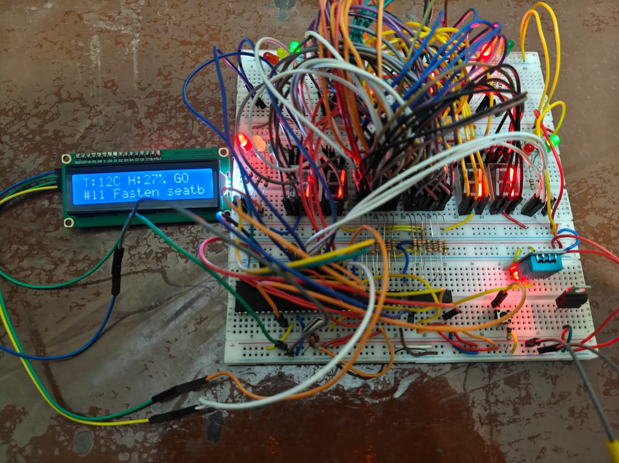

Figure.1

Simulation software:
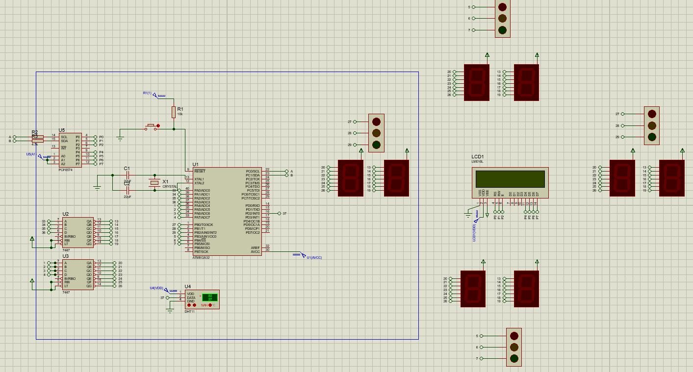
Technical Analysis of the Traffic Light Control System
The circuit is a sophisticated Embedded System built around the ATmega32 microcontroller. It integrates environmental sensing, advanced communication protocols, and multiplexed display driving to manage a four-way traffic light system.

1. The Control Unit (Brain of the System)
The heart of the circuit is the ATmega32 (U1), an 8-bit AVR RISC-based microcontroller.
Oscillator Circuit: A crystal oscillator (X1) with two 22pF capacitors (C1, C2) provides the clock signal (typically $8MHz$ or $16MHz$) for synchronous operation.
Reset Circuit: A pull-up resistor (R1) and a push-button are connected to the RESET pin to allow manual system restarts.
JTAG Configuration: In the code, JTAG is disabled to free up PORTC pins for I/O and I2C communication.

2. Display and Output Subsystems
A. 7-Segment Displays & Decoders (Time Countdown)
To display the countdown for each traffic light, the circuit uses 7-Segment Displays.

7447 BCD-to-7-Segment Decoders (U2, U3): These are used to reduce the number of microcontroller pins required. By sending a 4-bit Binary Coded Decimal (BCD) signal from PORTA, the decoders drive the displays.
Multiplexing Logic: The microcontroller outputs the "Tens" digit and "Units" digit simultaneously. The units digit is displayed on the right and the tens on the left, ensuring clear readability for drivers.
B. Traffic Light LEDs
The traffic lights (Red, Yellow, Green) for the four directions are connected to PORTB.
The logic follows a specific sequence: Green (40 to 4s) $\rightarrow$ Yellow (3 to 1s) $\rightarrow$ Red (40s).
Current-limiting resistors (like those seen near the DHT11) are used to protect the LEDs from overcurrent.

3. Communication and User Interface
A. I2C LCD Interface (Liquid Crystal Display)
The system features a 16x2 LCD (LCD1) to display temperature, humidity, and safety warnings.
PCF8574 I/O Expander (U5): This is the most efficient part of the design. Instead of using 7-8 pins to drive the LCD, the PCF8574 uses the I2C protocol (Serial Data - SDA and Serial Clock - SCL).
The ATmega32 communicates with the PCF8574 via pins PC0 and PC1, which then controls the LCD's data and command pins
4. Environmental Sensing
A. DHT11 Sensor (U4)
A DHT11 sensor is connected to pin PD2.
It operates on a Single-Bus (One-Wire) serial protocol.
The ATmega32 triggers the sensor, which then sends 40 bits of data representing the current Temperature and Humidity levels. These are processed and displayed on the LCD in real-time.

5. Functional Summary (Working Principle)
1. Initialization: The MCU initializes the I2C bus, the LCD, and the I/O ports.
2. Sensing Loop: Every few seconds, the MCU polls the DHT11 for environmental data.
3. Control Logic: The MCU executes the timing for the traffic lights. It updates the 7-segment displays via PORTA and toggles the LEDs via PORTB.
4. Interrupts/Updates: While counting down, the update_system_smart() function ensures the LCD keeps scrolling through warnings (e.g., "Fasten Seatbelt") and updating weather data without pausing the traffic timer.

Project Program Listing
The following is the complete C source code of the project, written for Atmel Studio 7 with the AVR-GCC toolchain targeting the ATmega32 at 8 MHz. The code is structured into initialization, I2C driver, LCD driver, DHT11 driver, multiplexing, and the main control loop.

#define F_CPU 8000000UL
#include <avr/io.h>
#include <util/delay.h>
#include <stdio.h>

#define LCD_ADDR 0x40
#define EN 2
#define RS 0
#define BL 3
#define DHT_PIN PD2

const char* warnings[] = {
"Focus on road ",
"No Phone Driving",
"Stay in Lane ",
"Fasten Seatbelt "
};

uint8_t warning_index = 0;
uint8_t T = 25, H = 50;
uint8_t timer_5sec = 5; // جعلناها 5 لتبدأ الشاشة بالعمل فوراً

// --- دالات I2C و LCD ---
void i2c_init() { TWSR = 0x00; TWBR = 0x20; TWCR = (1 << TWEN); }
void i2c_write(uint8_t data) { TWDR = data; TWCR = (1 << TWINT) | (1 << TWEN); while (!(TWCR & (1 << TWINT))); }
void i2c_start() { TWCR = (1 << TWINT) | (1 << TWSTA) | (1 << TWEN); while (!(TWCR & (1 << TWINT))); }
void i2c_stop() { TWCR = (1 << TWINT) | (1 << TWSTO) | (1 << TWEN); }

void lcd_send(uint8_t val, uint8_t mode) {
uint8_t high = (val & 0xF0) | mode | (1 << BL);
uint8_t low = ((val << 4) & 0xF0) | mode | (1 << BL);
i2c_start(); i2c_write(LCD_ADDR);
i2c_write(high | (1 << EN)); _delay_us(1); i2c_write(high & ~(1 << EN));
i2c_write(low | (1 << EN)); _delay_us(1); i2c_write(low & ~(1 << EN));
i2c_stop();
}

void lcd_init() {
_delay_ms(100);
lcd_send(0x02, 0); // تهيئة نمط 4-بت
lcd_send(0x28, 0); // سطرين ومصفوفة 5x7
lcd_send(0x0C, 0); // تشغيل العرض وإخفاء المؤشر
lcd_send(0x01, 0); // مسح الشاشة
_delay_ms(5);
}

void lcd_print(const char *str) { while (*str) lcd_send(*str++, 1); }

void read_dht11() {
uint8_t bits[5] = {0,0,0,0,0}, i, j, timeout;
DDRD |= (1 << DHT_PIN); PORTD &= ~(1 << DHT_PIN); _delay_ms(18);
PORTD |= (1 << DHT_PIN); DDRD &= ~(1 << DHT_PIN); _delay_us(30);
timeout = 200; while((PIND & (1 << DHT_PIN)) && --timeout);
if (timeout == 0) return;
timeout = 200; while(!(PIND & (1 << DHT_PIN)) && --timeout);
timeout = 200; while((PIND & (1 << DHT_PIN)) && --timeout);
for (i = 0; i < 5; i++) {
for (j = 0; j < 8; j++) {
timeout = 200; while (!(PIND & (1 << DHT_PIN)) && --timeout);
_delay_us(35);
if (PIND & (1 << DHT_PIN)) bits[i] |= (1 << (7 - j));
timeout = 200; while ((PIND & (1 << DHT_PIN)) && --timeout);
}
}
if (bits[0] != 0) { H = bits[0]; T = bits[2]; }
}

void update_system_smart() {
char buffer[20];
if (timer_5sec >= 5) {
read_dht11();
lcd_send(0x80, 0);
sprintf(buffer, "T:%uC H:%u%% ", T, H);
lcd_print(buffer);
lcd_send(0xC0, 0);
lcd_print(warnings[warning_index]);
warning_index = (warning_index + 1) % 4;
timer_5sec = 0;
}
timer_5sec++;
}

void display_segments(uint8_t val) {
PORTA = ((val / 10) << 4) | (val % 10);
}

int main(void) {
MCUCSR = (1<<JTD); MCUCSR = (1<<JTD); // تعطيل JTAG لضمان عمل PORTC
DDRA = 0xFF; DDRB = 0xFF; DDRD &= ~(1 << DHT_PIN);

i2c_init();
lcd_init();

// إظهار رسالة ترحيب سريعة فور التشغيل
lcd_send(0x80, 0);
lcd_print("Initializing...");
_delay_ms(500);

while (1) {
// أخضر
PORTB = (1 << PB2) | (1 << PB3);
for (int i = 40; i >= 4; i--) {
display_segments(i);
update_system_smart();
_delay_ms(900);
}
// أصفر
PORTB = (1 << PB1) | (1 << PB3);
for (int i = 3; i >= 0; i--) {
display_segments(i);
update_system_smart();
_delay_ms(900);
}
// أحمر
PORTB = (1 << PB0) | (1 << PB5);
for (int i = 40; i >= 0; i--) {
display_segments(i);
update_system_smart();
_delay_ms(900);
}
}
}

Code Logic & Technical Explanation
1. Preprocessor & Definitions
The code starts by defining the CPU frequency ($8MHz$) and the I2C address for the PCF8574 (LCD driver). It also defines a list of safety warnings and system parameters for the DHT11 sensor connected to pin PD2.

2. I2C & LCD Communication Layer
To save GPIO pins, the system communicates with the LCD via the I2C Protocol.
i2c_init / i2c_write: Handles the low-level data transfer between the ATmega32 and the I2C expander.
lcd_send: Sends data in 4-bit mode. It splits each byte into two "nibbles" (High and Low) to ensure compatibility with the LCD controller while using minimal wiring.

3. Environmental Sensing (DHT11)
The function read_dht11 implements a precise timing protocol (One-Wire). It triggers the sensor by pulling the line low, then reads 40 bits of data to extract the Temperature (T) and Humidity (H) values, which are then stored for display.

4. 7-Segment Display Control
void display_segments(uint8_t val) {
PORTA = ((val / 10) << 4) | (val % 10);
}
This is a highly efficient way to drive two digits using one port. It divides the number into Tens (shifted to high pins) and Units (sent to low pins), driving the 7447 Decoders connected to the displays.

5. Smart System Update
The update_system_smart function acts as a background task. Every 5 cycles, it refreshes the LCD with:
Real-time weather data ($T$ and $H$).
Rotating safety warnings (e.g., "Fasten Seatbelt") to keep the driver engaged without stopping the traffic timer.

6. Main Control Loop (Traffic States)
The main function first disables JTAG to free up PORTC for I2C. It then enters an infinite loop, cycling through three states:
1. Green State: Activates Green LEDs; counts down from 40 to 4.
2. Yellow State: Activates Yellow LEDs; counts down from 3 to 0.
.Red State: Activates Red LEDs; counts down from 40 to 0.3
Datasheet of Component

ATmega 32:
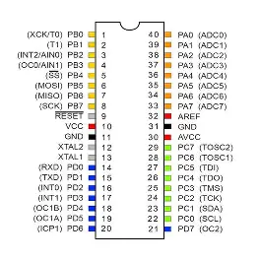
LCD:
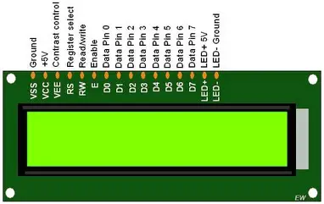

Decoder 7447:
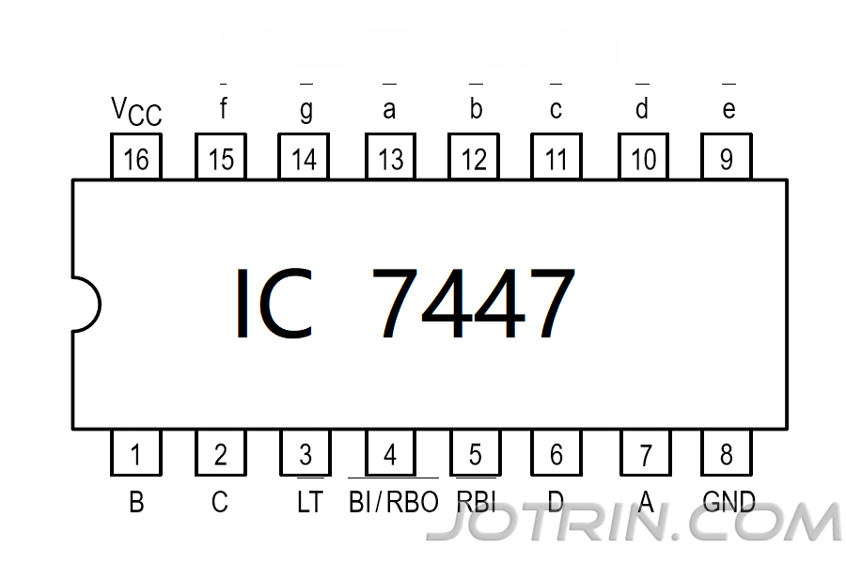

References:
ATmega32 Datasheet,
Microchip Technology Inc., Available at: https://www.microchip.com

Muhammad Ali Mazidi, Sarmad Naimi, Sepehr Naimi,
“AVR Microcontroller and Embedded Systems: Using Assembly and C”, Pearson Education.

DHT11 Temperature and Humidity Sensor Datasheet,
Available at: https://www.datasheet4u.com

Hitachi,
“HD44780 LCD Controller Datasheet” (for 16x2 LCD).

Frank Vahid and Tony Givargis,
“Embedded System Design: A Unified Hardware/Software Introduction”, Wiley.

Proteus Design Suite Documentation,
Labcenter Electronics, Available at: https://www.labcenter.com

Arduino & AVR Tutorials (for embedded concepts),
Available at: https://www.electronicwings.com

